200 W Frameless BLDC Motor
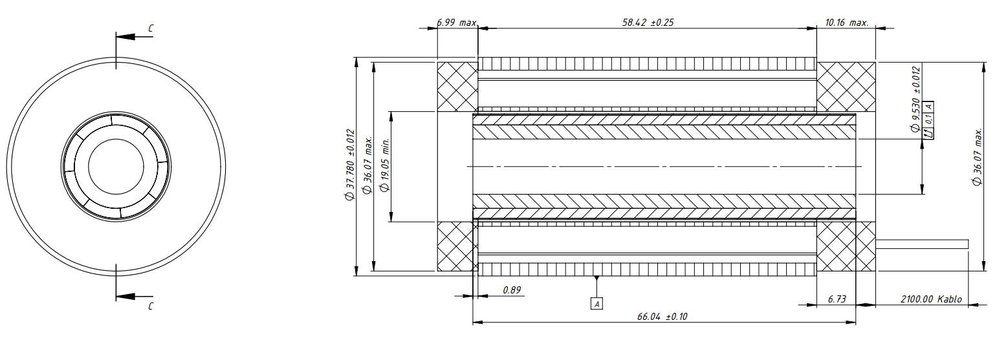
Basic Motor Parameters
Rated Power | W | 200
Rated Speed | rpm | 6000
Rated Torque | Nm | 0.25
Rated Current | A | 2.2
Rated Voltage | V | 120
No-Load Speed | rpm | 8500
Max. Efficiency | % | ~83
Electrical Parameters
Number of Phases |  | 3
Number of Poles |  | 8
Torque Constant (KT) | Nm/A | 0.124
Back EMF Constant (KE) | Vs/rad | 0.13
Terminal Resistance Phase to Phase (±%10) | mΩ | 1.9
Terminal Inductance Phase to Phase (±%30) | mH | 1.4
Thermal Data
Ambient Temperature | °C | -40...+85
Max. Winding Temperature | °C | +155
Physical Parameters
Outer Diameter | mm | 37.780
Shaft Diameter | mm | N/A
Max. Lenght | mm | 75.57
Weight | gr | 100
Motor Connection
N/A | N/A
Sensor Connection
N/A | N/A
Connector Articles
Power | N/A
Signal | N/A

